https://en.wikipedia.org/wiki/List_of_integrated_circuit_packaging_types

Flat packages
Small outline packages
Chip-Scale packages
Ball grid array
Transistor, diode, small pin count IC packages

SOIC = Small Outline Integrated Circuit
https://en.wikipedia.org/wiki/Small_Outline_Integrated_Circuit

Narrow SOIC (JEDEC)

Wide SOIC | The difference is mainly related to the parameters WB and WL
MSOIC | SOIC variant, available only for 8-pins and 10-pins ICs, is the mini-SOIC, also called micro-SOIC. This case is much smaller with a pitch of only 0.5mm.
SOJ | is a version of SOIC with J-type leads instead of gull-wing leads.
SOP | a family of smaller form factors , with pin spacings less than 1.27 mm  Plastic small outline package (PSOP)  Thin small outline package (TSOP)  Thin-shrink small outline package (TSSOP)

SOIC-8-N
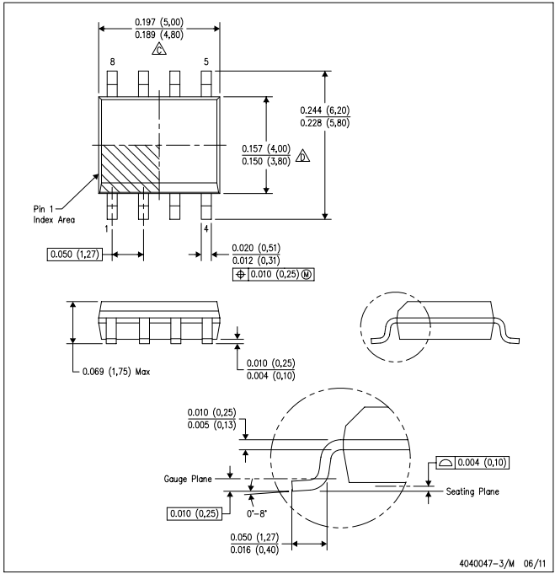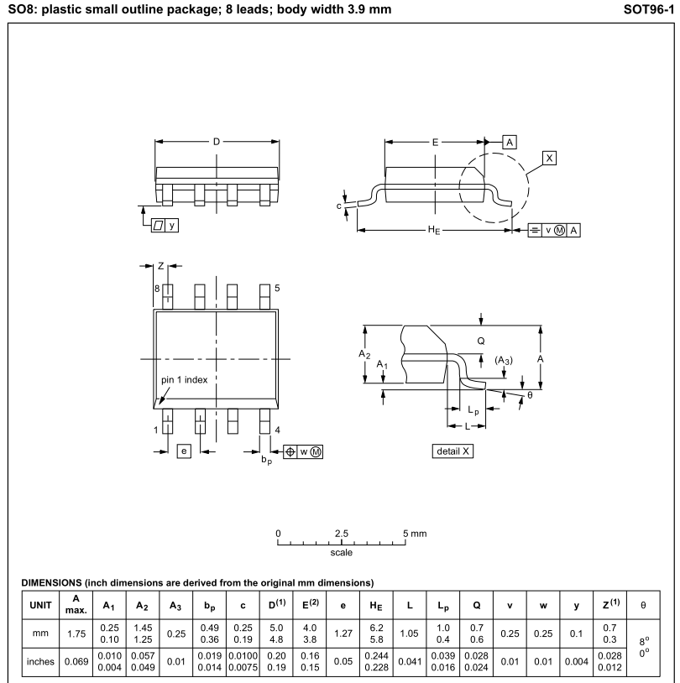

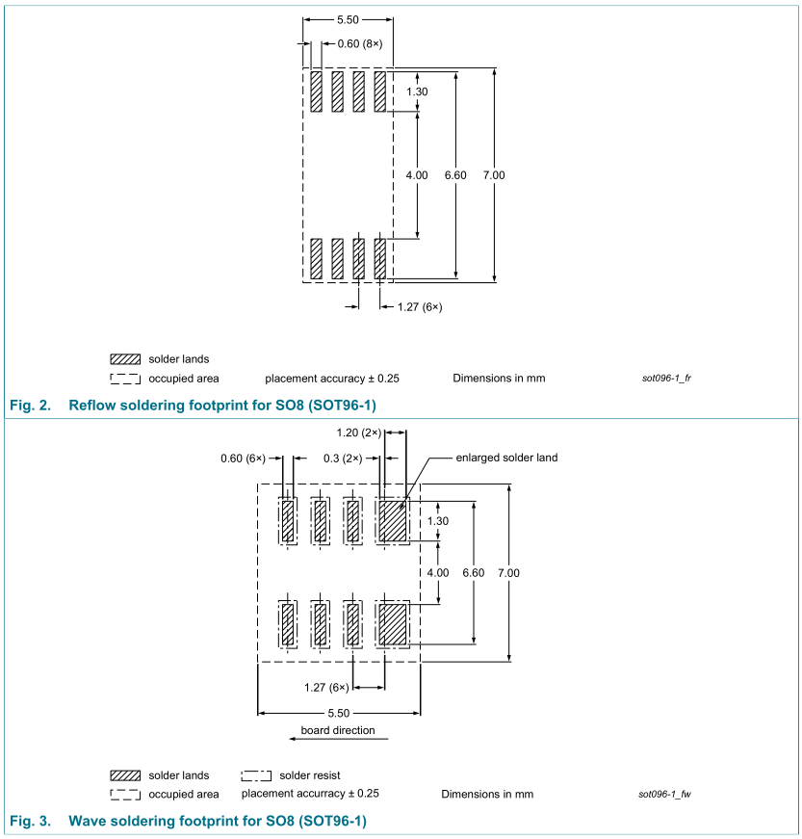

SOIC-16-W
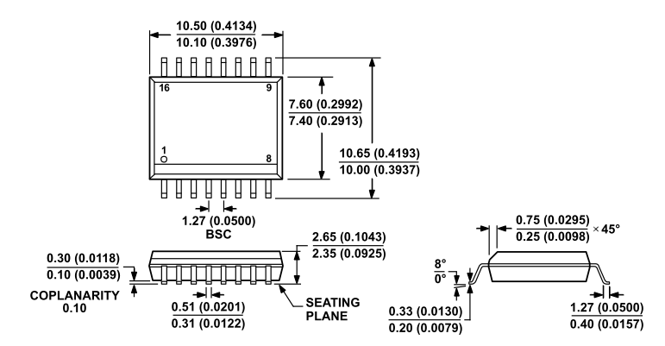

TSSOP-24
http://www.analog.com/en/design-center/packaging-quality-symbols-footprints/package-index/sop-small-outline-package/tssop-thin-1_2mm.html
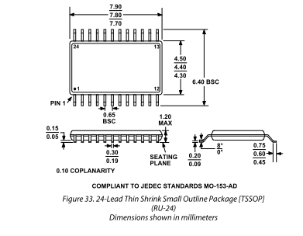

QFP = Quad Flat Package
TQFP = thin quad flat pack | T is for thin(er, 1.0 mm)
LQFP = Low Profile Quad Flat Package | L is for Low-profile (1.4 mm)

LQFP-32
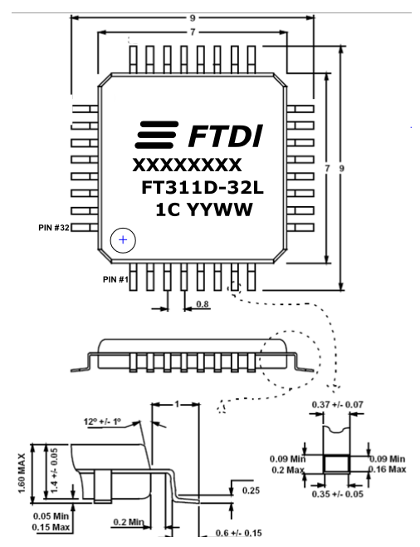

LQFP-64
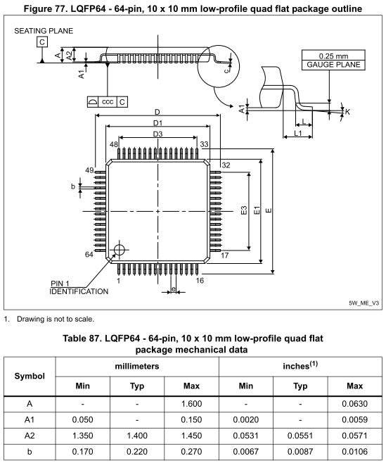
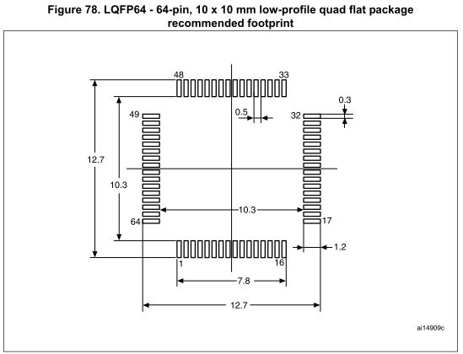

SOT = Small Outline Transistor

SOT23-5

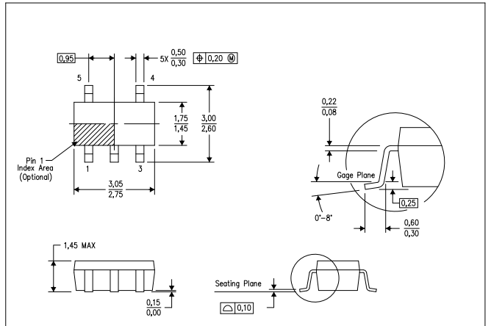

SOT23
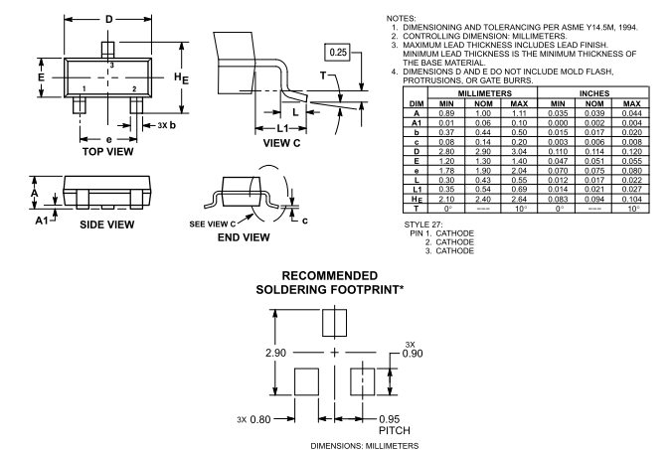

DO = Diode

DO-214AC, also known as SMA,is the smallest size.
DO-214AA, also known as SMB,is the middle size.
DO-214AB, also known as SMC,is the largest size.

